

**Hospital Management**

ON

Submitted in partial fulfillment of the requirements of the degree of

**Bachelor of Engineering**

**(Information Technology)**

By

**Vanshika Ambwani -Roll No (02)**

Under the guidance of

**Mrs. Dipti Karani**



**Department of Information Technology**

**VIVEKANAND EDUCATION SOCIETY’S INSTITUTE OF TECHNOLOGY, Chembur, Mumbai 400074**

**(An Autonomous Institute, Affiliated to University of Mumbai)**



**April 2024**

# Certificate

This is to certify that project entitled

**Hospital Management**

## Miss. Vanshika Ambwani( Roll No. 02 )

In fulfillment of degree of BE. (Sem. VI) in Information Technology for Project is approved.

**Prof. Mrs. Dipti Karani Project Mentor External Examiner**

**Dr.(Mrs.)Shalu Chopra H.O.D Dr.(Mrs.)J.M.Nair Principal**

Date: / 4/2025 Place: VESIT, Chembur College Seal

*Declaration*

We declare that this written submission represents my ideas in my own words and where others’ ideas or words have been included, I have adequately cited and referenced the original sources. I also declare that I have adhered to all principles of academic honesty and integrity and have not misrepresented or fabricated or falsified any idea or data or fact or source in my submission. I understand that any violation of the above will be cause for disciplinary action by the Institute and can also evoke penal action from the sources which have thus not been properly cited or from whom proper permission has not been taken when needed.

- - - - - - - - - - -

**(Signature)**

Vanshika Ambwani - Roll No (0 2)

Dept. of Information Technology

## Abstract

The Hospital Appointment Management System is a full-stack web application designed to streamline the process of booking and managing appointments in hospitals and clinics. The system allows patients to view available doctors, browse by specialization, and schedule appointments efficiently. Built using React and TypeScript for the frontend, Flask for the backend, and MongoDB Atlas for the database, the application ensures real-time responsiveness and a smooth user experience. The platform emphasizes a modular design, intuitive appointment flow, specialty-based filtering, and integrates seamlessly with a MongoDB-powered doctor and schedule catalog.

Dept. of Information Technology

**Contents**

* **Introduction**
* Introduction
* Objectives
* Motivation
* Scope of Work
* Feasibility Study
* **Literature Survey**
* Introduction
* Problem Definition
* Existing Systems
* **Design and Implementation**
* Requirement Gathering
* Proposed System Design
* Technology Stack
* User Interface
* **Results and Discussion**
* Home Page
* Topic and Subtopic Pages
* Resource Management
* Observations
* **Conclusion and Future Scope**
* Conclusion
* Future Scope
* **Bibliography**

## ACKNOWLEDGEMENT

The project report on **“Hospital Management System”** is the result of consistent guidance, unwavering moral support, and dedication that our group received throughout the development of this project. We take this opportunity to express our heartfelt gratitude to everyone who served as a source of motivation and inspiration during the preparation of this project.

First and foremost, we extend our sincere thanks and deep respect to **Dr. (Mrs.) Shalu Chopra**, Head of Department, **Dr. Manoj Sabnis**, Deputy HOD, and our project guide **Mrs. Dipti Karani** for their invaluable inputs, continuous encouragement, and insightful guidance which helped us in completing this project successfully.

We are also profoundly grateful to **Vivekanand Education Society’s Institute of Technology** for providing us with a positive and resourceful academic environment, as well as the necessary infrastructure to explore, learn, and grow.

## Chapter 1:Introduction

### Introduction

The **Hospital Appointment Management System** is designed to simulate a real-time appointment scheduling platform for hospitals and clinics, with a focus on intuitive design, performance, and seamless backend integration. The system aims to simplify the process of booking medical appointments for patients while providing healthcare professionals with an organized and efficient way to manage their schedules.

### Objectives

* Enable category-wise browsing and product filtering
* Provide a dynamic product display system
* Facilitate backend management using Flask and MongoDB
* Implement a fast and responsive frontend
* Ensure seamless routing and UI interaction using React

### Motivation

Inspired by the need for real-time, user-friendly grocery shopping experiences, this project aims to offer Hospital Management platform to demonstrate full-stack development skills and database integration.

### Scope of the Work

The project includes a dashboard, admin page, surgeon page, patient page, book an appointment

### Feasibility Study

Using open-source tools such as Flask, MongoDB, and React ensures technical feasibility. The modular nature of the system allows for scalability and future feature additions.

**Chapter 2: Literature**

## Survey

### Introduction

Many existing hospital appointment systems prioritize performance, user experience, and real-time scheduling. This survey evaluates similar healthcare platforms and their underlying technical architectures to understand best practices and identify areas for improvement in our system.

### Review of Literature Survey

* Evaluation of Patient Satisfaction in Digital Healthcare Platforms in India  
  **Authors**: Sarvesh Jadhav, Ray Titus, Tina Babu, R. Chinnaiyan (2023)  
  **Objective**: To analyse patient preferences and satisfaction levels concerning digital healthcare platforms in India.  
  **Work Done**: The study conducted surveys focusing on attributes such as ease of appointment booking, user interface design, and accessibility of medical services. It emphasized the significance of user-friendly applications in enhancing patient satisfaction.  
  **Conclusion**: A seamless interface and accessible features significantly influence patient satisfaction and frequent use of digital healthcare platforms.
* Critical Success Factors for Hospital Appointment Scheduling Systems in India: An Exploratory Study  
  **Authors**: Venkatesh Ganapathy, Chithambar Gupta (2023)  
  **Objective**: To identify key factors contributing to the successful deployment of hospital appointment systems in Indian healthcare institutions.  
  **Work Done**: The research explored models for appointment systems focusing on infrastructure readiness, digital adoption, and cost-effectiveness.  
  **Conclusion**: For sustainable implementation, strategic investment, streamlined processes, and patient-centric design are essential.
* Smart Hospital Appointment System Development  
  **Authors**: Abdulhaseeb H. Abdulmalik, Faisal Sulaiman A. Alghafri, Mohammed J. Yousif (2021)  
  **Objective**: To develop a smart appointment scheduling application that addresses challenges in managing patient flow.  
  **Work Done**: The study proposed an intelligent appointment system with features like real-time availability, doctor filtering, and patient reminders.  
  Conclusion: The developed system provided a user-centric solution, improving overall efficiency in patient appointments.
* Digital Health Services: A Boon or Burden for Urban Traffic and Environment?  
  **Authors**: Mateo Samudio Lezcano, Corey D. Harper, Destenie Nock, Gregory V. Lowry, Constantine Samaras (2023)  
  **Objective**: To assess the environmental and logistical impact of digital health service deliveries such as e-consultations and home visits.  
  **Work Done**: Using urban data from Seattle, the study analyzed shifts in traffic patterns and emissions due to adoption of telehealth and e-health services.  
  **Conclusion**: While digital health services can reduce physical visits, strategic implementation is needed to prevent logistical inefficiencies.
* Development of Smart Appointment Booking System for Hospitals  
  **Authors:** Savali Patil, Anjali Joshi, Aachal Shinde, Abhishek Rathod, Madhuri Kawarhe (2023)  
  **Objective**: To improve current hospital appointment systems by integrating intelligent scheduling and automated notifications.  
  **Work Done**: The system developed allowed patients to book appointments based on doctor availability, while providing admins insights into patient traffic patterns.  
  Conclusion: The solution enhanced operational efficiency and improved appointment management.

## Chapter 3 : Design and Implementation

### Introduction

This chapter presents the outcomes of the **Hospital Appointment Management System** implementation, including cost estimates, feasibility study results, and a detailed analysis of the platform's effectiveness in streamlining hospital operations and improving patient engagement. The observations and remarks highlight key findings, system performance, and recommendations for future enhancements to expand its functionality and impact.

### Requirement Gathering

**Functional Requirements:**

* Browse Doctor Specializations  
  Users can view categories such as General Physician, Cardiologist, Dermatologist, etc.
* View Doctor Listings  
  Display a list of available doctors with details like name, specialization, experience, and consultation time.
* Load Doctor and Schedule Data from MongoDB  
  Doctor profiles, available time slots, and patient appointments are dynamically fetched from MongoDB.
* Specialization-wise Filtering  
  Users can filter doctors based on their specialization for quick and relevant appointment booking.

**Performance Requirements:**

* High responsiveness
* Low latency
* Mobile compatibility

### Proposed Diagram

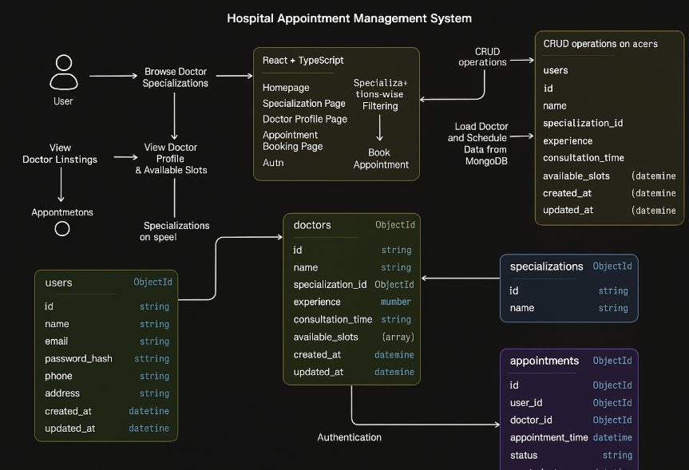

### Software Requirements

* Frontend: React + TypeScript
* Backend: Flask
* Database: MongoDB
* Tools: VS Code, Postman, GitHub

## 

## Chapter 4 Results and Discussion

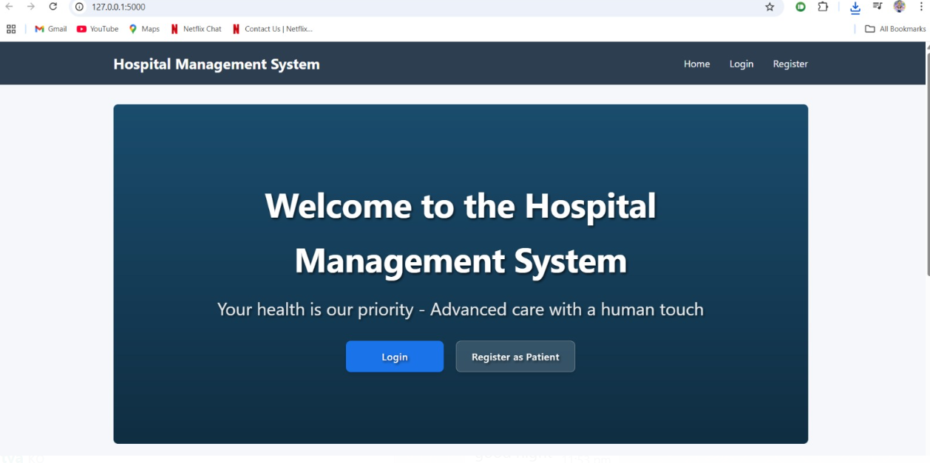

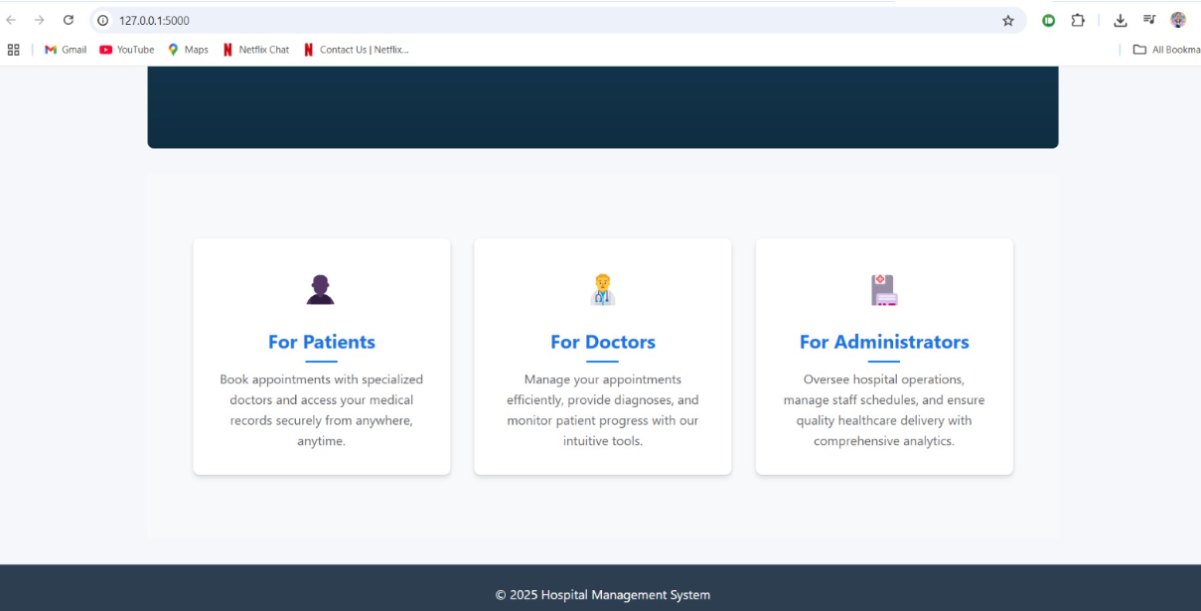

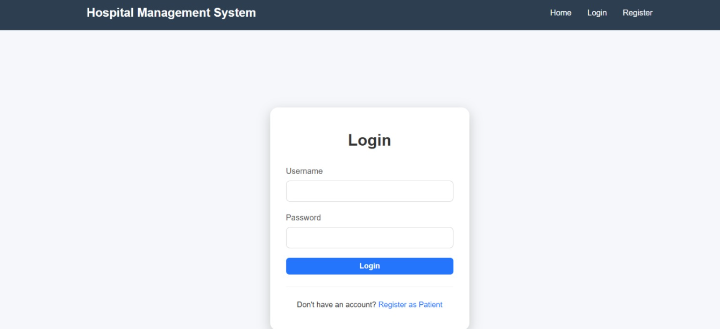

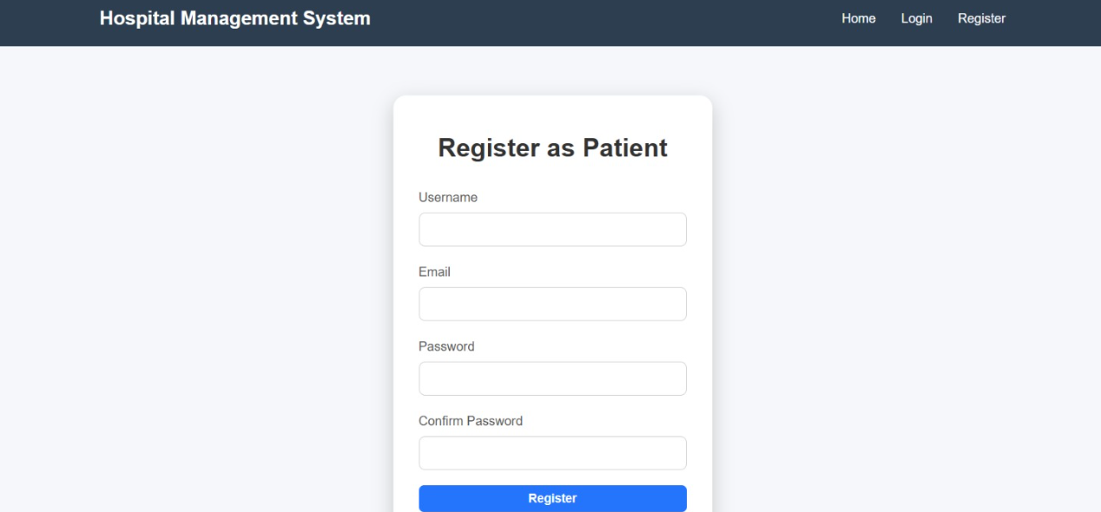

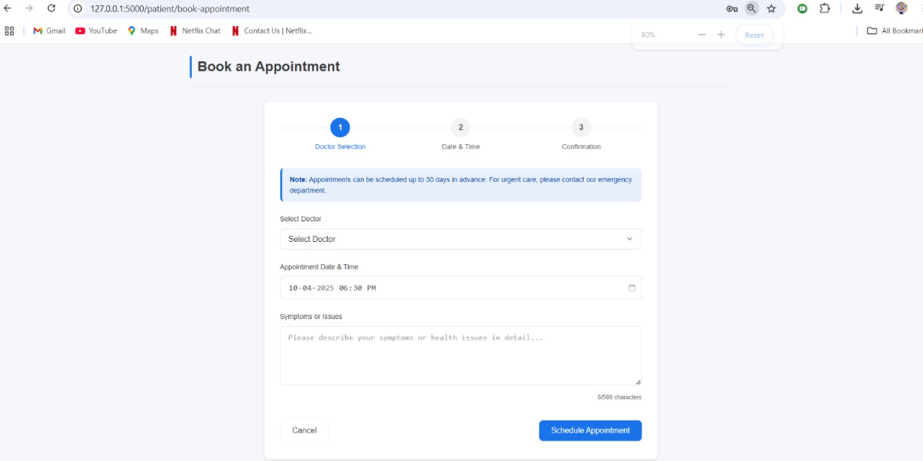

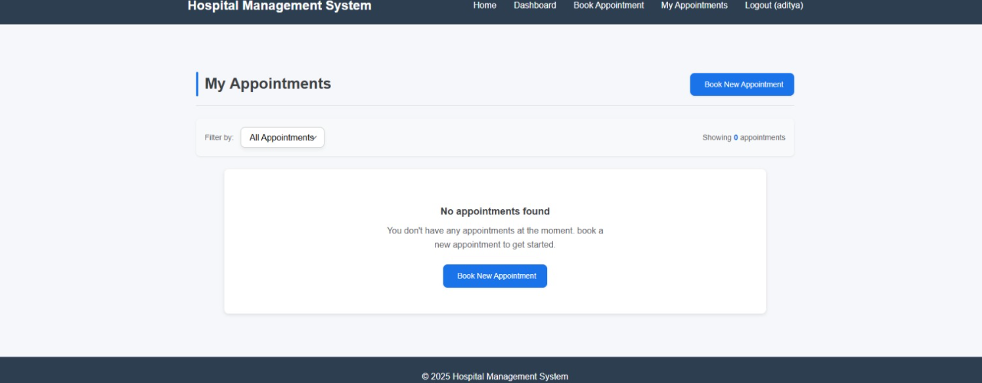

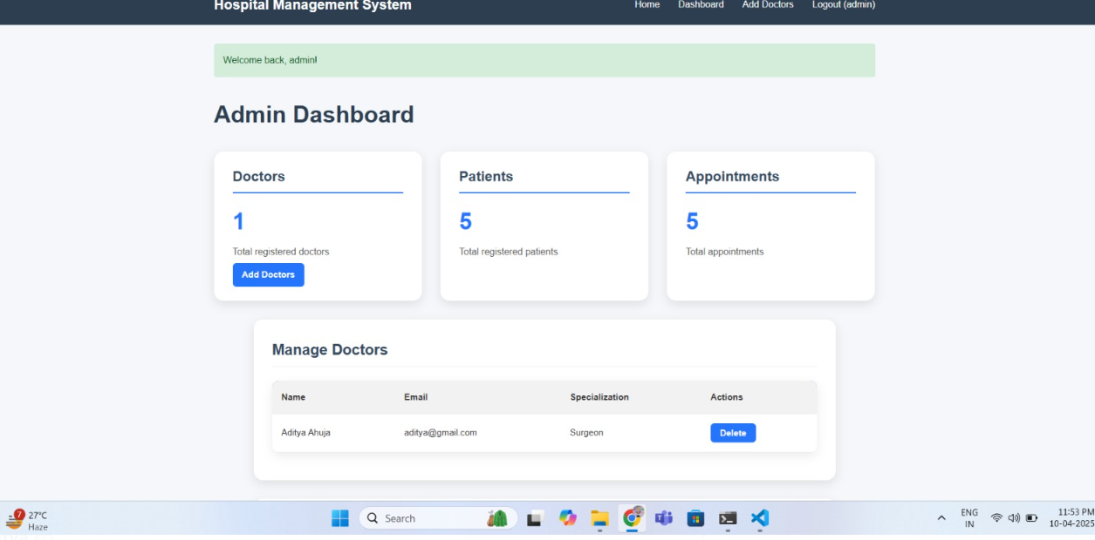

4.6 Observations

* User interface is intuitive and quick to load
* System is modular and easily extensible

## Chapter 5: Conclusion

### Conclusion

The **Hospital Appointment Management System** effectively demonstrates the integration of a **modern frontend** with a **robust backend** and a **cloud-based NoSQL database**. It mirrors a **real-time appointment scheduling experience** for patients and healthcare professionals, and serves as a foundational model for building scalable medical platforms.

### Future Scope

* Integrate payment gateway
* Real-Time Notifications
* AI-Powered Recommendations

Suggest doctors based on patient’s symptoms or past appointments.

* Telemedicine Integration

Enable video/audio consultations through platforms like Zoom, Jitsi, or WebRTC.

**Bibliography**

[1] J. Marynissen and E. Demeulemeester, “Literature review on multi-appointment scheduling for patients in hospitals,” *KU Leuven, Faculty of Business and Economics*, 2019.

[2] L. Bartlett, S. Rumbold, R. Banks, M. Hayward, and K. Darley, “Exploring patient experience of online general practice appointment booking,” *Journal of Medical Internet Research*, vol. 26, Jan. 2024.

[3] A. Almalki, A. Almohammed, S. Alomar, and M. Alzahrani, “Evaluation of the Mawid web-based medical appointment system in Saudi Arabia: A cross-sectional study,” *Journal of Multidisciplinary Healthcare*, vol. 16, pp. 57–65, 2023.

[4] M. Kumar and P. Agarwal, “Literature review on appointment scheduling in hospitals’ management,” *Archives of Clinical and Biomedical Research*, vol. 5, no. 4, pp. 456–461, 2021.

[5] R. E. Yilmaz and B. C. Oztaysi, “Hospital management maturity models: Literature review,” *ResearchGate*, Oct. 2021.